**Site MAP**

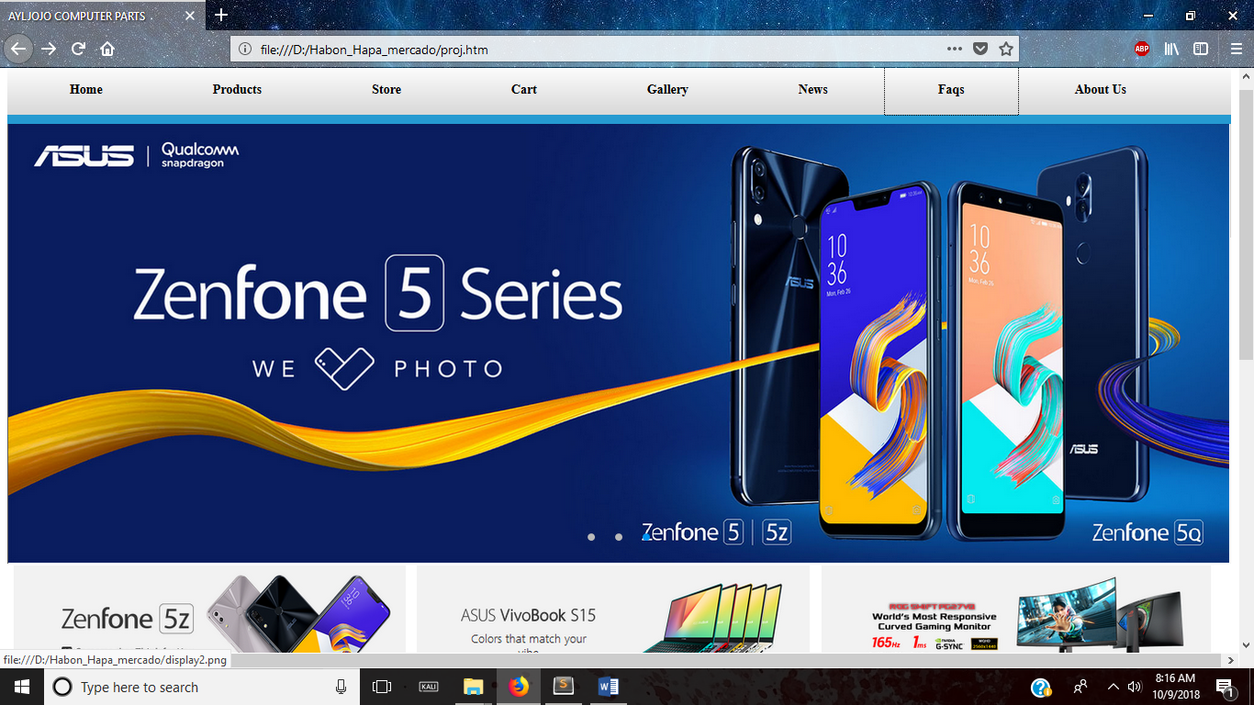

The Homepage, this is where you can navigate through the website. It also shows intresting products you might like to look at.

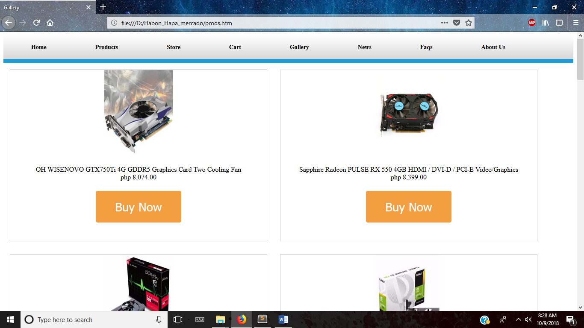

The Product page, This is where you may browse the store and buy them or add the items you like in the cart

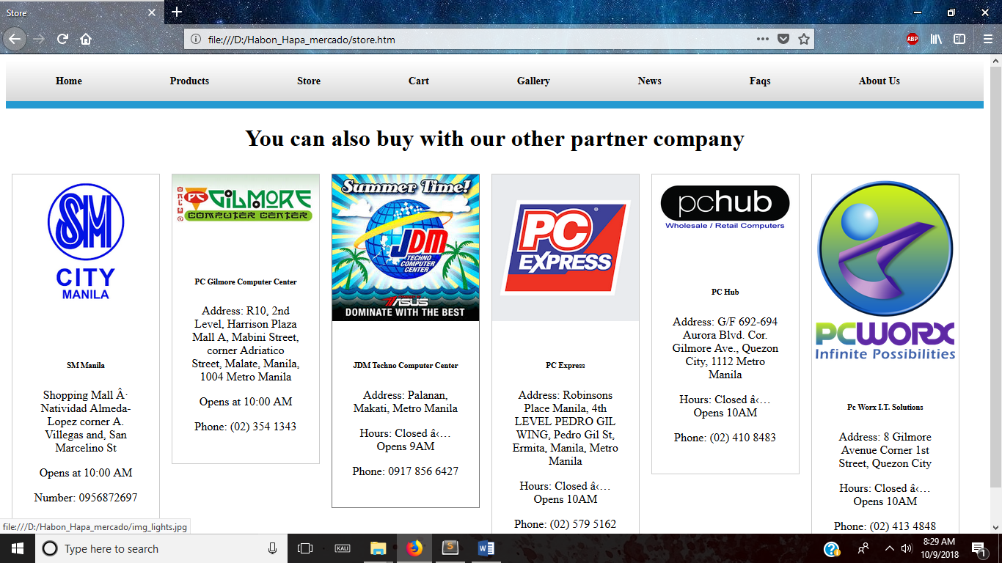

The Store Page, this previews our parter store which our items can be also bought.

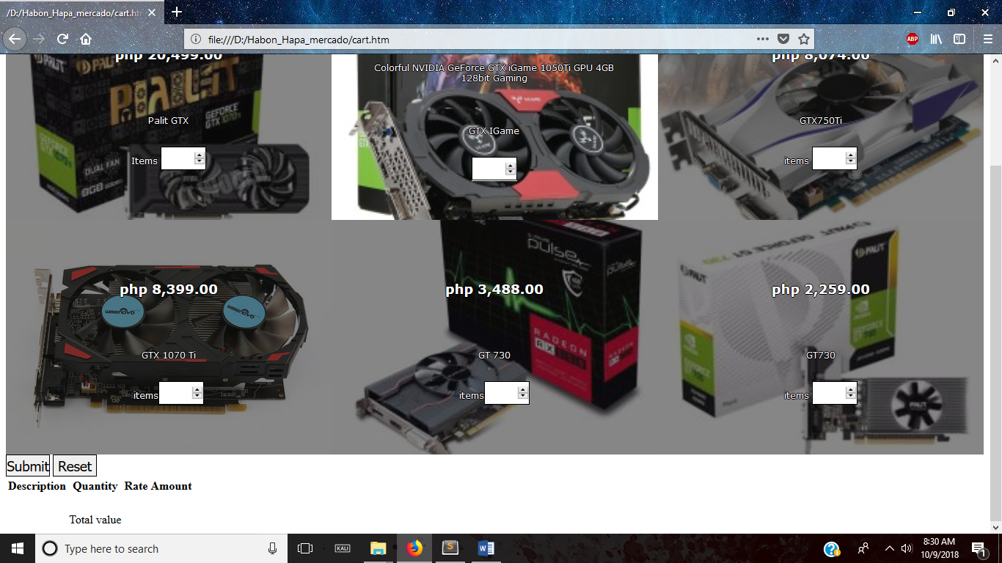

The Cart page, this is where you can also buy and add the quantity. You may see the total Price of the product you wanted to buy

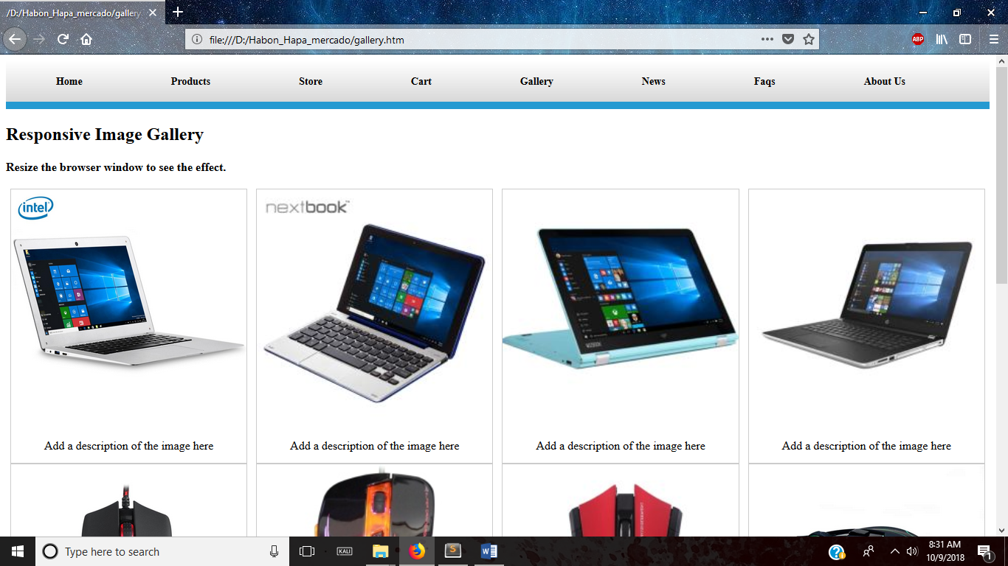

The Gallery page, this page shows products, and when you click them descriptions of the products would appear.

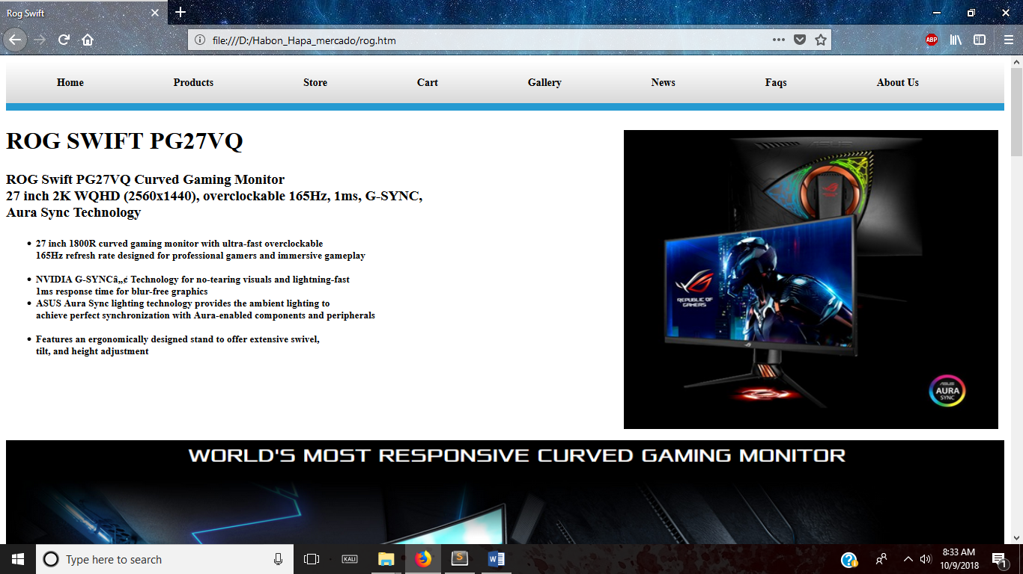

Sample description page, it is previewed when you click on an item and shows its description.

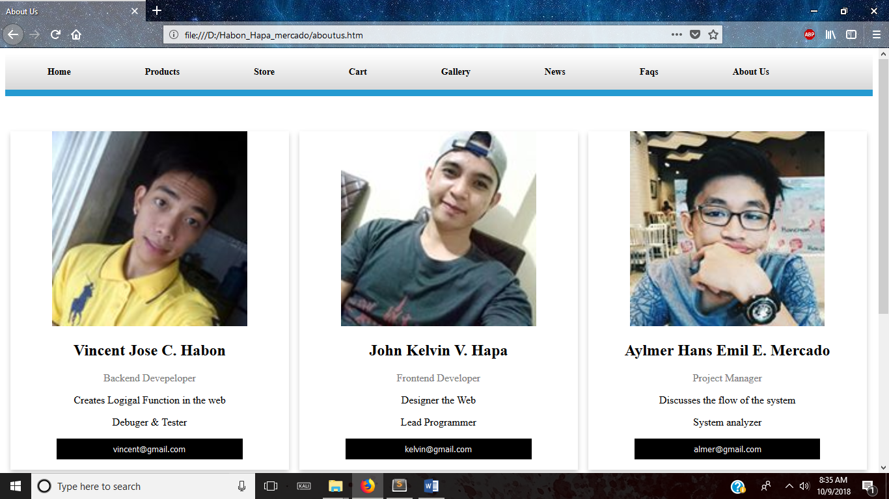

About us page, this shows the creators of the website and shows a little bit of their information.

**CONTRIBUTION**

**JavaScript/HTML – Vincent Jose C. Habon**

**CSS – John Kelvin K. Hapa**

**Documentation – Aylmer Hans Emil R. Mercado**